QUERY
Customer table
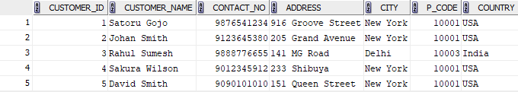
Employees table
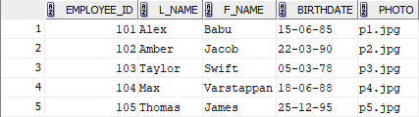
Orders
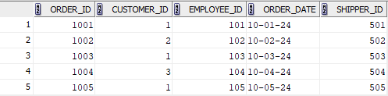
1.List all customers in ascending order by their names
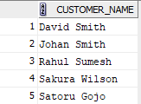
2. Retrieve a list of orders with the oldest ones appearing first, sorted by order date in ascending order.
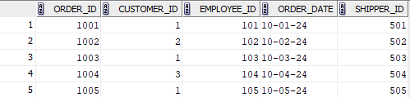
3. Find the employees who were born after 1980 and list them in descending order of their birthdates.
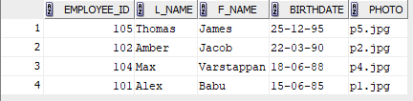
4. List orders placed by customers from 'USA' in descending order of the order date.
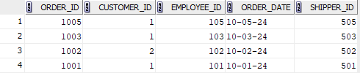
5.Calculate the total number of orders placed by each customer.
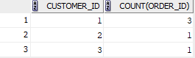
6.List the cities with the total number of customers.
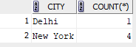
7.List customers who have placed more than 2 orders.
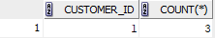
8.Display cities with more than 3 customers.
